From: UHS Information Security
To: UHS Vendor/Contractor

Subject: New/Updated/Upgraded Software/Appliance/Equipment Security questions
Please answer the questions listed below, which will assist the information security team to complete a security assessment of the item in question. Please feel free to substitute server, database, or appliance for application as necessary to suit the situation.

- Will this application be hosted on premise, in the cloud, or at the vendor’s site?

Fully hosted by the customer on premise.

- Please provide a graphic representation (Network Wire Diagram) of the communications/network infrastructure associated with the systems communications requirements. Label all ports (such as port 80 and/or 443) and services (such as SFTP, TLS 1.1, etc.) that are used or required.

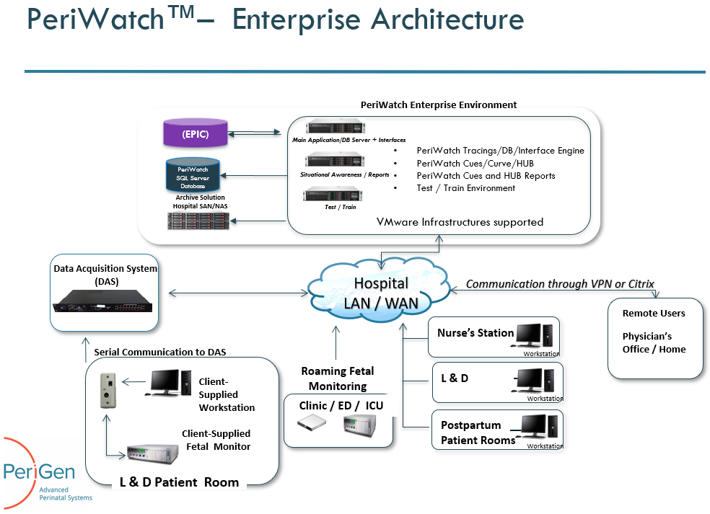

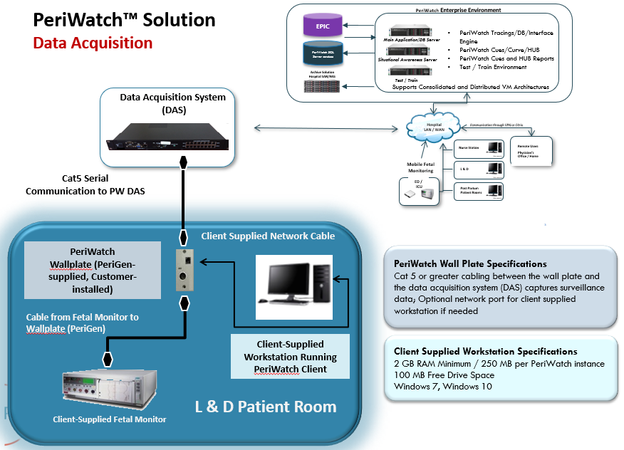

- Does the application comprise HIPAA data? Other sensitive data? PII? PCI?

Yes. ADT inbound for basic patient identifiers, Patient clinical data (vitals, tracings, charted OB data)

- How will the vendor/contractor connect to the application:
VPN? Dedicated circuit? Internet? Not required?

PeriGen recommends the use of SecureLink which provide controlled and secure connectivity between vendors and customer in the Medical domain. For more information please refer to https://www.securelink.com/industries/healthcare/

- If this is an upgrade, what ports are currently opened? What ports are allowed? What ports are required? Please supply documentation with port requirements and justification.

New Install.

- Is this an Upgrade/New installation/Migration from an old version to a new version?

New Install.

- Does the vendor/contractor perform authenticated IP scans of your system/environment? What tool is used? A copy of the results will be required.

No.

- Does the vendor/contractor perform application-level scans? What tool is used? A copy of the results will be required.

No.

- What OS and Version does this application require? Can it be upgraded as a new version/patches are released? Who is responsible for testing new version/patch compatibility?

Windows 2012 R2 (server) and Windows 10 (client). Windows 2016 support in Q3-4 2019.

- Does this application support SSO? AD integration? Federation? LDAP? Who performs the integration?

SSO with Epic - Yes. AD Authentication – Yes. Federation – No, LDAP – Yes. Configuration is done by PeriGen Technical Operations team with parameters provided by the customer.

- Does this application require remote access? Is remote access required for users? Is remote access required for support? Is this Agent Based? Always on or session based? Is remote access Auditable? Is remote access Alertable? Is remote access SecureLink capable?

Remote access for users is optional and is only supported with thin-client technology managed by the customer (Ex: Citrix Portal).
Remote access is required for support via SecureLink which provides auditing capabilities.

- Does this system allow the use of Anti-virus software? Anti-malware software? What specific vendors? Who is responsible for installation, maintenance, etc.?

Yes, we have yet to have a conflict or problem with any AV vendor platform. Some exclusions are required for performance tuning on the server only.

- Does this system allow for the installation of monitoring agents such as Solar winds, Splunk, SCCM?

Yes.

- Does this system allow for the installation of Auditing GPOs?

Yes

- Does this system communicate securely both inside and outside of the corporate network?

PeriWatch Tracing version 2019.1 encrypts all standard data between server and client.
Decision Support components (Cues, Curve, HUB) will have all communication encrypted as of version 2019.1.1 (July 2019).

- Does this application require “Middle ware”; such as, Java, Flash, I.E., or Adobe reader? Does it require a specific version of middle ware? Can it be patched or upgraded? Who is responsible for maintenance and upkeep?

The system only relies on .Net Framework and related MS modules which are updated with MS patches. Other included software like Rhapsody interface engine is packaged with the software and only updated by PeriGen support personnel (if needed).

- Does this application require any Microsoft Office products? Can it use an add-on or plug in instead? If so, what version? Can it be patched? Who is responsible for patching MS Office suite? Please provide documentation showing requirements for MS office suite or parts of the suite.

No.

- Does this application require a Certificate? Who provides the Certificate? Is it greater than SHA1?

Yes. The customer would need to provides/generate the SH256 certificate.

- Does this application require any services, such as:
FTP? SFTP? FTPS? Telnet? TLS? SSL?
Note: UHS does not allow SSLv2, SSLv3 or FTP in the corporate environment.

TLS only.

- Does this application require dedicated hardware, such as:

OVA? UHS owned/built? Is this a hardware appliance?

UHS will need to provide several VMs where the application/DB will be installed. PeriGen will provide all other hardware (data acquisition components).

- Will this Application require Updates? Who performs them? What is the process? What’s the timeline?

Maintenance and Enhancement versions are typically released once or twice a year. Any such version or urgent patch is performed by PeriGen Technical Operations/Support staff with the approval and coordination with the customer/clinical staff. Any version or patch is always deployed to the TEST environment and only deployed to PROD upon customer acceptance.

- Does this application require a Vendor password? What is the process for updates? Does the application require any Admin accounts? Rights? Unique naming?

Yes. The application is installed with a built-in special user account that is subject to a policy re. password length and change frequency (configurable).

